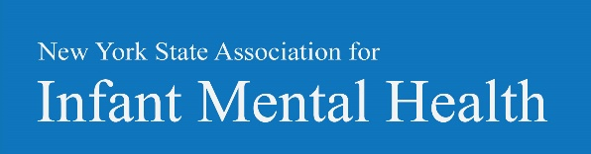
Endorsement is a credentialing system that supports and recognizes the knowledge and ability of professionals who work with or on behalf of infants and young children up to age five and their families. This process uses a nationally recognized set of standards and competencies that define best practice and guide professional development across disciplines.
The intent of the NYS-AIMH Endorsement is to recognize and document the development of infant and family professionals within an organized system of culturally sensitive, relationship-based, Infant Mental Health learning and work experiences.
To learn more about the NYS-AIMH Endorsement please visit us online at www.nysaimh.org
This training may be used towards gaining your NYSAIMH Endorsement. Here is the relevant information that will assist you while filling out your portfolio.

The Troubled Triangle: The Developmental Neurobiology of Addiction, Attachment and Trauma with Kurt White, LICSW, LADC, CGP
These areas were highlighted in this training:
Trauma Separation Loss Attachment Cultural Competency Relationship-Based Practice
These competencies are met through this training:
Pregnancy and early parenthood
Infant-and young child development and behavior
Biological, neurological, psychosocial, or environmental factors impacting development
Family relationships and dynamics
Disorders of infancy and early childhood (mental health)
Adult mental health, learning, and cognitive functioning
Risk and resiliency
Observation, screening, assessment, diagnosis and treatment planning/intervention
Collaboration, community resources, and delivery systems
Law, ethics, regulations, guidelines
Supervision (reflective)
Leadership/administration
Data, research, evaluation, program development, policy
Other:

